**Level 1: PC Tower Case**

**Outline**

Learn about the internals of a standard PC case by examining physical samples and selecting and labeling images found on-line. Gain deeper knowledge by researching and reporting on specific components.

**Questions**

1. Find one (or more) images that clearly show the internals of a PC Tower Case.   
   (i.e. Google images using keywords “PC Case Internals”)

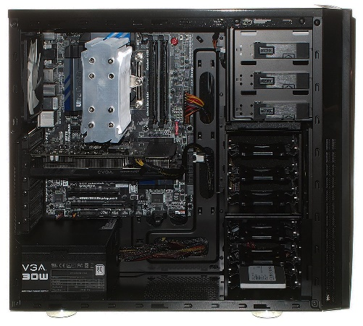

1. Clearly label the following components (using arrows) on your image of the PC case internals:
   1. Motherboard
   2. Power Supply
   3. Hard Disk Drive
   4. Optical Disk Drive (e.g.DVD)
   5. USB Expansion Ports
   6. Monitor Port
   7. Audio Ports
   8. Ethernet Port
   9. Cooling Fan

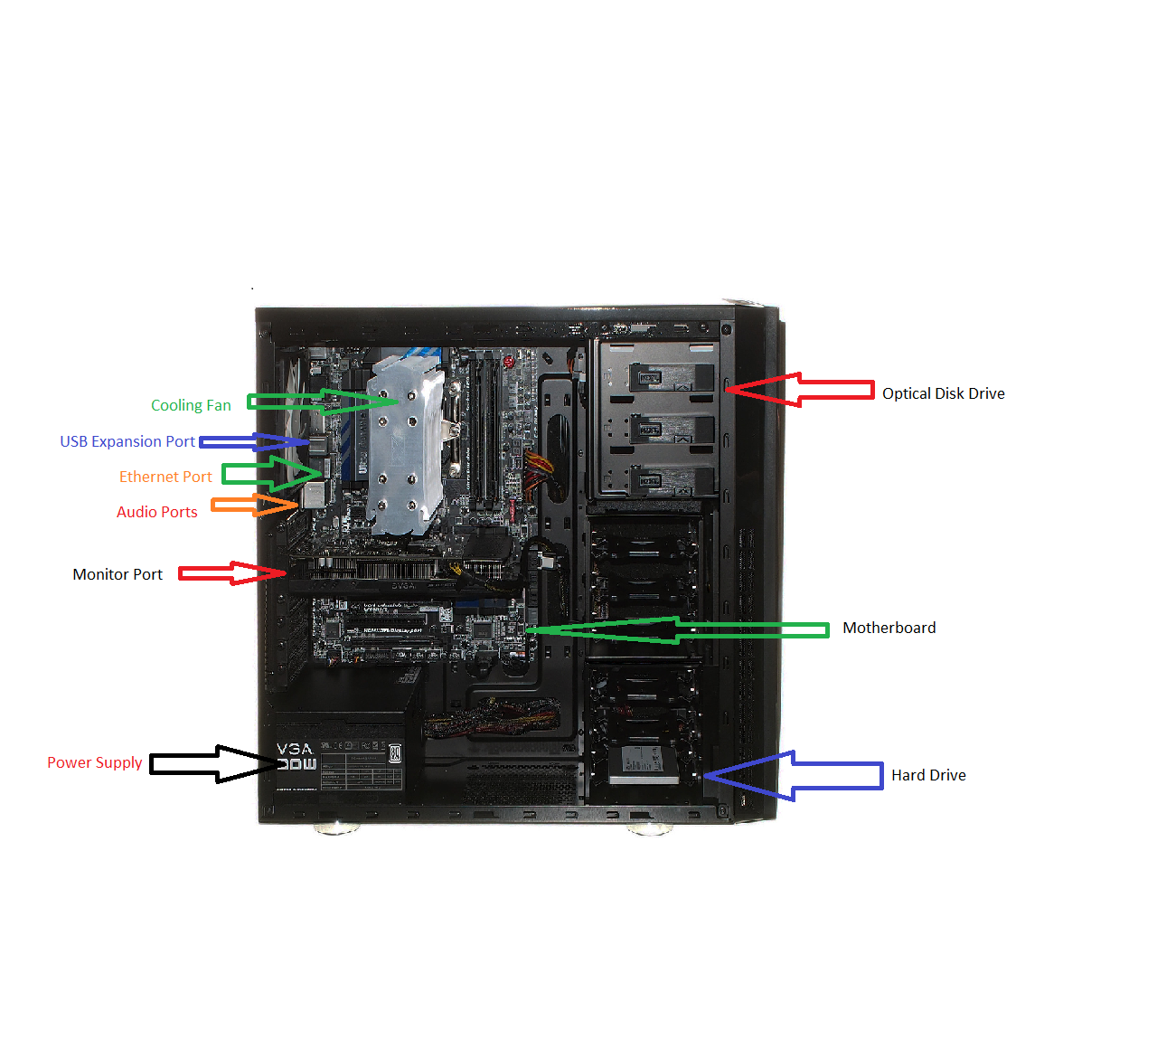

1. Research more in-depth about “Motherboards”. Make notes on the following:
   1. What different versions are currently available (speed and capacity)

Currently, most desktops or laptops contain an ATX motherboard in which is the layout, design and size of the motherboard. However, motherboards do not form any sorts of speed due to its main function is to hold each of the ports, cables, processor and ram together. The motherboard does not form any kind of speed.

* 1. How the component has changed since the 1980’s

The motherboard which was firstly known as the Planar Breadboard was brought into the technology world at 1981 by IBM. The Planar had chips which was only used to connect the CPU and RAM of the computer together. They were connected by cassette tapes and supplier parts. The Planar motherboard was also called the “IBM compatible” standard like many other modern-day motherboards. Present day motherboards are significantly different from the IBM motherboard due to the immense features of the newer motherboards like adding integrated circuit packaging in 1990 and including peripherals like the mouse and keyboard. Furthermore, including the mouse and keyboard with the motherboard gave both devices lower power consumption so it would not consume the power of the desktop. Most monitors now come in various sizes and perform many different functions/features. Higher grade motherboards can now help boost performance in any sorts of tasks.

1. Research more in-depth about “Hard Disk Drives”. Make notes on the following:
   1. What different versions are currently available (speed and capacity)

Hard Disk Drives range from 5400 rpm to 7200 rpm. These drives can also expand from 500GB to 6 TB.

* 1. How the component has changed since the 1980’s  
       
     Since the 1980’s many components have been changed by having expandable storage. At the start of the 1980’s a common hard disk drive will be around 10 MB with very slow speeds which is unnoticeable with today’s technology. Later on in the 1990’s, hard drives have varying sizes which each computer can then put into the hard drive slots.

**NOTE:**

* Download the on-line version of this module (from the class GitHub repository)
* Questions for Level 2 and Level 3 are in the on-line version of this module
* Provide your answers in a MS Word, PowerPoint, or equivalent format
* Upload your answers to your personal GitHub repository

**Level 2: PC Motherboard**

**Outline**

Learn about the structure of a standard PC motherboard by examining physical samples and selecting and labeling images found on-line. Gain deeper knowledge by researching and reporting on specific components.

**Questions**

1. Find one (or more) images that clearly show the layout of a PC Motherboard.   
   (i.e. Google images using keywords “PC Motherboard”)

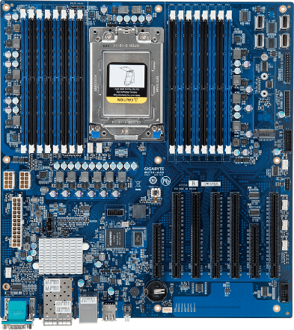

1. Clearly label the following components (using arrows) on your image of the PC motherboard:
   1. CPU (and fan)
   2. RAM Memory
   3. Disk Drive Interface (IDE or SATA)
   4. GPU Graphics Processor (either on-board or Graphics Card)
   5. Sound Processor (either on-board or Sound Card)
   6. Wi-Fi / Ethernet Network Interface (either on-board or Graphics Card)

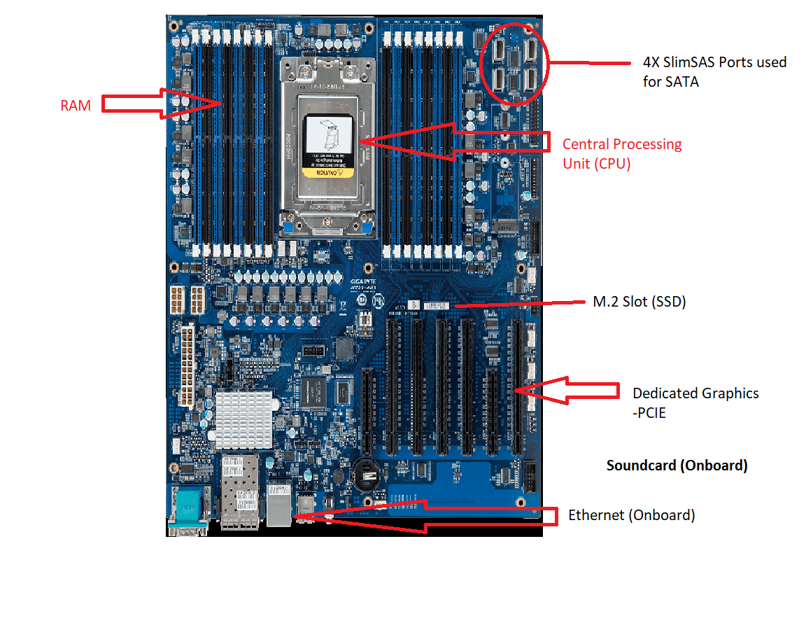

1. Research more in-depth about “CPU Processor Chip”. Make notes on the following:
   1. What different versions are currently available (speed and capacity)

The processor chip in todays age has many kinds of varying speeds and different kinds of core counts. Today, most chips contain only 4 cores with 3.4 Ghz Furthermore, usually better processors have much higher speeds and core counts but is usually is worth a lot of money. Certain processors have a 6-core processor which can range from 8-32 cores. The speed of any kind of CPU can range from 2.9 Ghz – 4.9 Ghz. In addition, the processor can overclock up to 8 Ghz at maximum.

* 1. How the component has changed since the 1980’s

Since the 1980’s, the CPU had undergone many changes. Before, the CPU had only 1 core which ran at 6 Mhz which is significantly low compared to the modern-day processors. 10 years later during 1990, the speeds of the core slightly increased to 8 Mhz. Later on in 1990, the speed increased to 20 Mhz. Furthermore in 1995, the multi core processor was introduced to help build more processing power and functions. Overtime, the CPU started to increase in its speed and cores to make processing much quicker and bring much quicker speeds to any sort of task.

1. Research more in-depth about “RAM Memory”. Make notes on the following:
   1. What different versions are currently available (speed and capacity)

RAM has evolved a lot over the years. The most common ram found in most computers is usually 6-8 GB as higher ram cost a lot more. The current generation of ram contains DDR4 memory which can achieve higher speeds and memory. RAM could increase to 16, 32, 64 and even 128 GB which can roughly cost around $1000. The standard speed of RAM is 2000 Mhz. The speed of ram could get up to 3200 Mhz.

* 1. How the component has changed since the 1980’s  
       
     RAM has significantly changed since the 1980’s. From 1982-1984 RAM was only 1 KB to 16 KB. From 1985, RAM has reached 512Kb to 612 KB. However, the speed of the RAM has stayed the same throughout each of the years at 20 Ghz. From 1995-1999, RAM has increased from 32 MB and 128MB with a speed of 25 Mhz. From then on RAM has began to increase over the 2000’s.